**Educational Qualification**

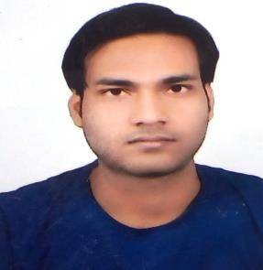

**CAREER OBJECTIVE**

* Seeking a position in a company where I can launch my career and build a valuable skill set.
* To get an opportunity where I can make the best of my potential and contribute to the organization’s growth

|  |
| --- |
| **NAVNEET**  **KUMAR VISHWAKARMA** |
| Address- New Colony Bairiahawa  Post – Gandhi Nagar Basti .  Pin Code- 272001 Distic- Basti  Email- [navneet1068@gmail.com](mailto:navneet1068@gmail.com) Mob- 6393124343 |
| **KEY SKILL**   1. Innovative ,Hardworking. 2. Computer & Accounting skills. 3. Office Management 4. Good Communication Skill |

|  |
| --- |
| **WORKING EXPERIENCE**   * ACCOUNTS AND SALES STAFF HANDLING AT MICROMAX / LAVA/NOKIA MOBILE DISTRIBUTOR BASTI *FROM JULY 2015 TO DEC 2020. * CURRENT WORING AT MP BIRLA PERFECT CEMENT CFA BASTI AS MANAGEMENT OFFICE * FROM JAN 2021 |
| **PERSONAL DETAIL** |
| **Father’s Name : Late-** Mr. Anil Vishwakarma |
| **Mother’s Name :** Radha Vishwakarma |
| **Gender :** Male |
| **Date of Birth :** 10/05/1995 |
| **Nationality :** Indian |
| **Language :** HINDI , ENGLISH |
| **Maritial Status :** unmarried |

|  |  |  |
| --- | --- | --- |
| **Name of Exam** | **From** | **Year of Passing** |
| th  10 | U.P.Board | 2009 |
| th  12 | U.P.Board | 2011 |
| B.Com | D.D.U. Gorekhpur University | 2014 |
| PGDCA | SWAMI VIVEKANAND UNIVERSITY | 2015 |